

Travlr Getaways

CS 465 Project Software Design Document
Version 2.0

Table of Contents

CS 465 Project Software Design Document 1
Table of Contents 2
Document Revision History 2
Instructions 2
Executive Summary 3
Design Constraints 3
System Architecture View 3
Component Diagram 3
Sequence Diagram 4
Class Diagram 4
API Endpoints 4
The User Interface 4

Document Revision History

Version | Date | Author | Comments
1.0 | 03/25/26 | Jas King | Added executive summary description, documented key design constraints and their development implications, and described overall system architecture using the provided component diagram.
2.0 | 04/05/26 | Jas King | Added sequence diagram and class diagram with written explanations, and documented REST API endpoints in the SDD.

Executive Summary

The Travlr Getaways web application is built using a contemporary full‑stack architecture that clearly delineates responsibilities across well-defined layers. This approach promotes scalability, maintainability, and long-term adaptability as business requirements evolve. The application leverages the MEAN stack, consisting of MongoDB for data storage, Express.js and Node.js for server-side processing, and Angular for client-side development.

The system consists of two primary user-facing components: a customer-facing website and an administrator single-page application (SPA). The customer-facing website allows users to browse available travel options, view trip details, and interact with general site content. This interface emphasizes responsiveness, performance, and intuitive design to ensure a positive end-user experience.

The administrator SPA is a secured Angular-based interface that enables authorized users to create, edit, and manage travel listings. Implementing the admin panel as a SPA enhances usability by providing dynamic content updates, improved responsiveness, and reduced server overhead compared to traditional multi-page applications. All administrative actions are performed through RESTful API calls rather than direct database access.

At the core of the system is a backend application built with Node.js and Express.js. This layer contains the business logic, processes client requests, enforces access control, and manages interactions with the MongoDB database. Together, these components form a modular and adaptable system that meets Travlr Getaways’ current requirements while supporting future enhancements.

Design Constraints

The development of the Travlr Getaways web application is influenced by several design constraints that guide its implementation. One major constraint is the required use of the MEAN stack, which dictates the technologies used across the application. While this limits alternative frameworks, it also provides consistency by utilizing JavaScript throughout the stack, improving development efficiency and reducing context switching.

Scalability is another critical constraint. The system must support increasing user traffic and data volume without requiring extensive architectural changes. This requirement influences decisions such as maintaining a stateless backend, decoupling client applications from server logic, and exposing functionality through RESTful APIs. Although these approaches require additional upfront planning, they enable horizontal scaling as demand grows.

Security introduces further constraints, particularly for the administrator SPA. Administrative functionality must be protected against unauthorized access through authentication, route protection, and request validation. These requirements increase development and testing complexity but are essential for maintaining data integrity and system security.

Finally, the academic nature of the project and its milestone-based delivery limit the early adoption of advanced optimizations. Architectural decisions therefore prioritize clarity, modularity, and correctness over performance tuning, ensuring that the system is understandable, extensible, and aligned with instructional objectives.

System Architecture View

Component Diagram

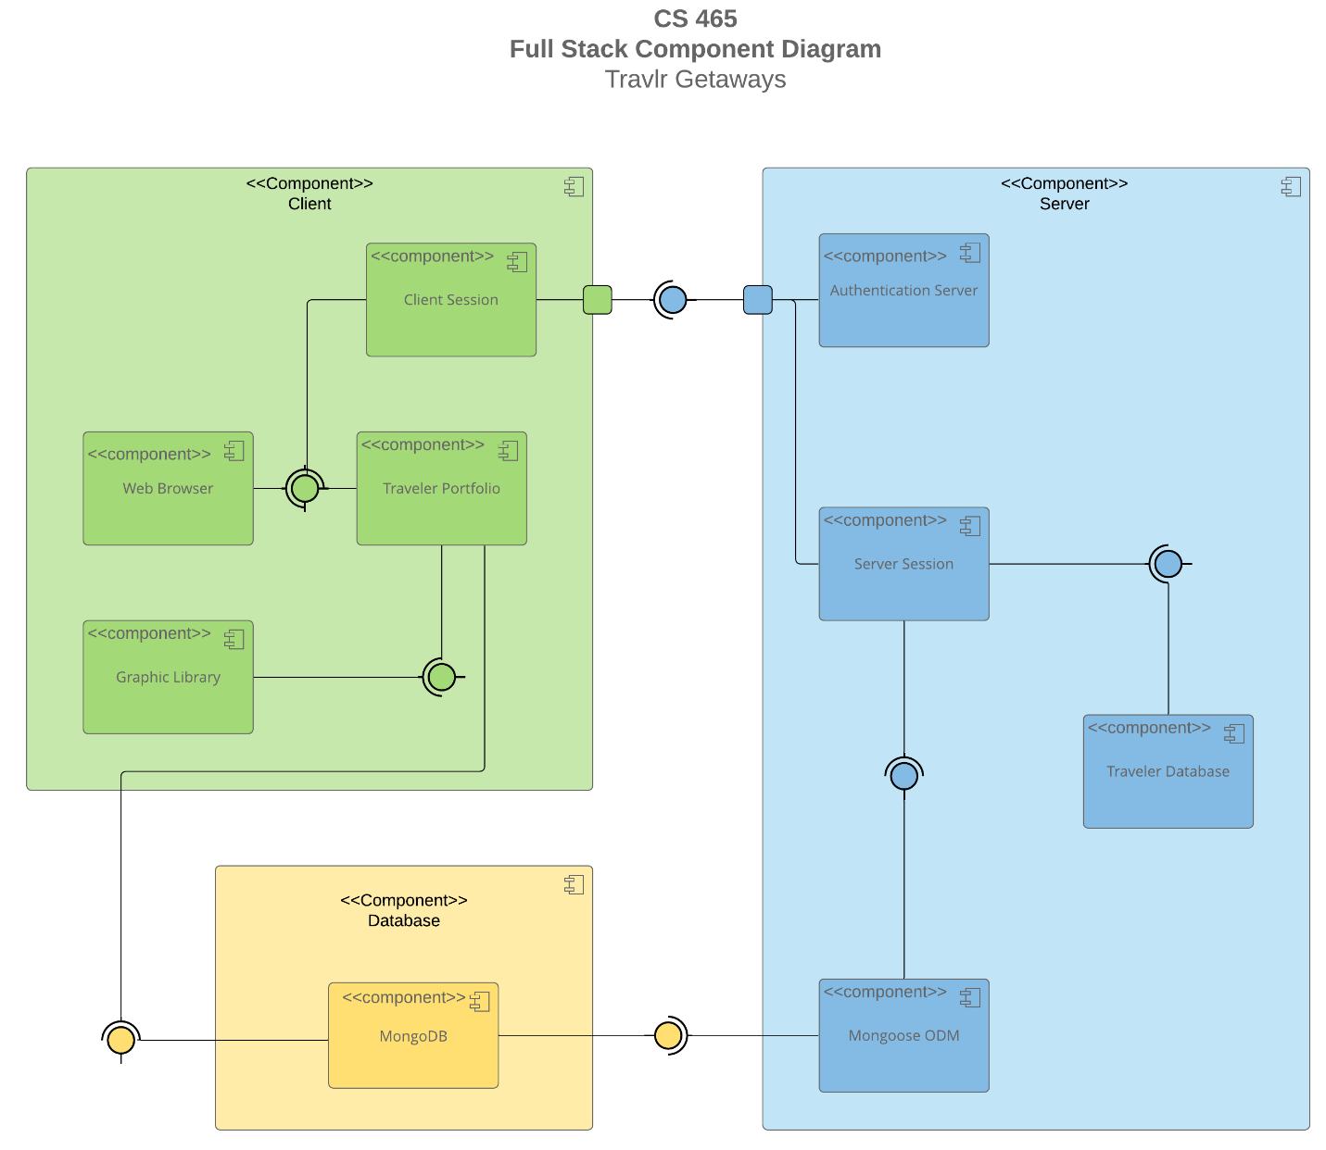

A text version of the component diagram is available: CS 465 Full Stack Component Diagram Text Version.

The Travlr Getaways application follows a layered architecture, as illustrated in the component diagram. The diagram depicts two client components, the customer-facing interface and the administrator SPA, communicating with a centralized application server through HTTP-based RESTful APIs.

The Node.js and Express.js application server functions as the orchestration layer, handling incoming requests, enforcing business rules, managing authentication and authorization, and mediating access to persistent data. The MongoDB database serves as the system’s data storage layer, storing trip information and administrative records.

All data access is restricted to the application server, ensuring consistent validation and controlled interaction with the database. This clear separation of concerns enhances maintainability, supports scalability, and enables future expansion without significant architectural restructuring.

Sequence Diagram

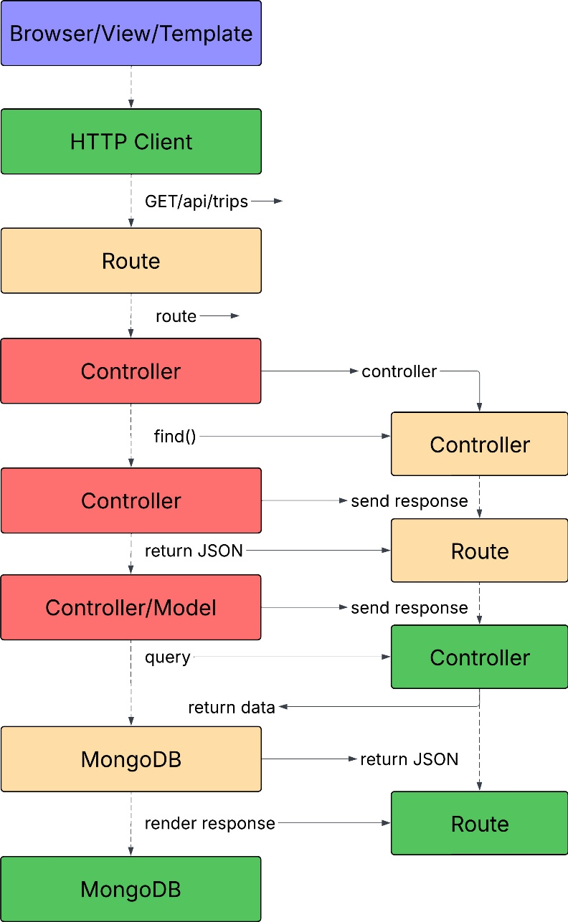

The sequence diagram illustrates the flow of a user request in the Travlr Getaways web application. When a user navigates to the Travel page, the browser sends an HTTP GET request to the /api/trips endpoint. The Express route receives the request and forwards it to the controller, which interacts with the Trip model using Mongoose to query the MongoDB database. The controller then returns a JSON response, which is sent back through the route to the client for rendering. This flow demonstrates clear separation between the view, routing, controller logic, and database access layers.

Class Diagram

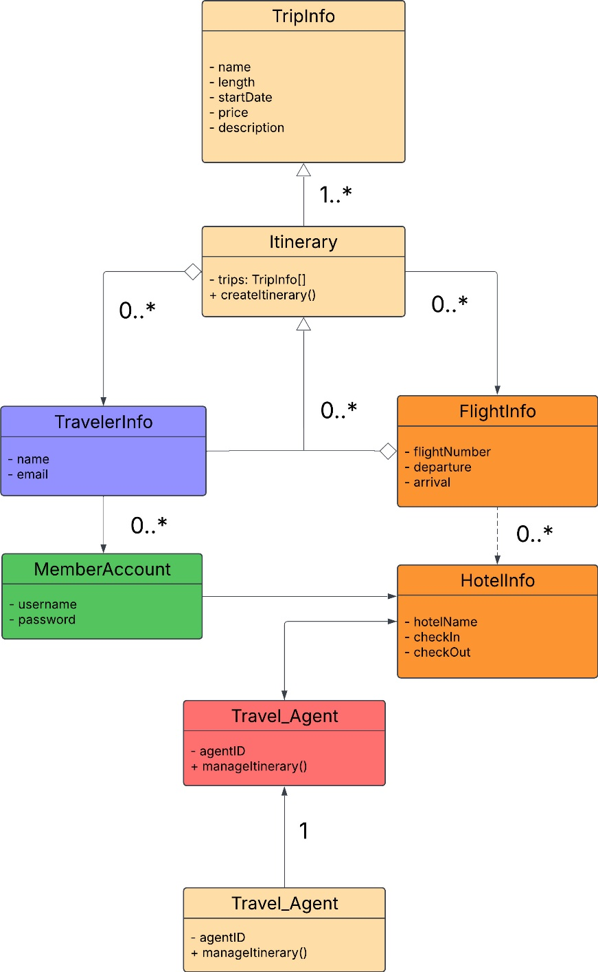

The class diagram represents the main JavaScript classes and their relationships in the Travlr Getaways application. TripInfo contains details about each travel offering, such as duration, price, and schedule. Itinerary aggregates trip information and may reference related classes like FlightInfo, HotelInfo, and CruiseInfo. TravellerInfo and MemberAccount represent user data, while Travel_Agent manages itineraries. This structure supports modular design and reflects how different aspects of travel planning interact within the application.

API Endpoints

The REST API exposes endpoints that allow client applications to retrieve trip data. The /api/trips endpoint returns a collection of all trips stored in MongoDB, while /api/trips/:tripId returns a specific trip based on a unique identifier. These endpoints enable separation between the front-end application and the data layer, allowing the API to be reused by different clients.

Method | Purpose | URL | Notes
GET | Retrieve all trips | /api/trips | Returns all active trips as a JSON array
GET | Retrieve single trip | /api/things/:tripId | Returns a single trip instance, identified by the trip ID

The User Interface

<Insert screenshots from the development of the SPA development to show the following: (1) a unique trip, added by you, (2) the Edit screen, and (3) the Update screen.>

<Summarize the Angular project structure and how it compares to the Express project structure. Be sure to describe the rich functionality provided by the SPA compared to a simple web application interaction. Describe the process of testing to make sure the SPA is working with the API to GET and PUT data in the database.>

